CREATE OR REPLACE PROCEDURE compile_plsql(

p_name VARCHAR2,

p_type VARCHAR2,

p_options VARCHAR2 DEFAULT NULL

) IS

v_stmt VARCHAR2(4000); -- Increased size for safety

BEGIN

-- Construct the SQL statement

v_stmt := 'ALTER ' || p_type || ' ' || p_name || ' COMPILE';

-- Add options if provided

IF p_options IS NOT NULL THEN

v_stmt := v_stmt || ' ' || p_options;

END IF;

-- Execute the dynamic SQL statement

EXECUTE IMMEDIATE v_stmt;

EXCEPTION

WHEN OTHERS THEN

-- Handle exceptions if needed

RAISE_APPLICATION_ERROR(-20001, 'Error compiling PL/SQL object: ' || SQLERRM);

END;

/

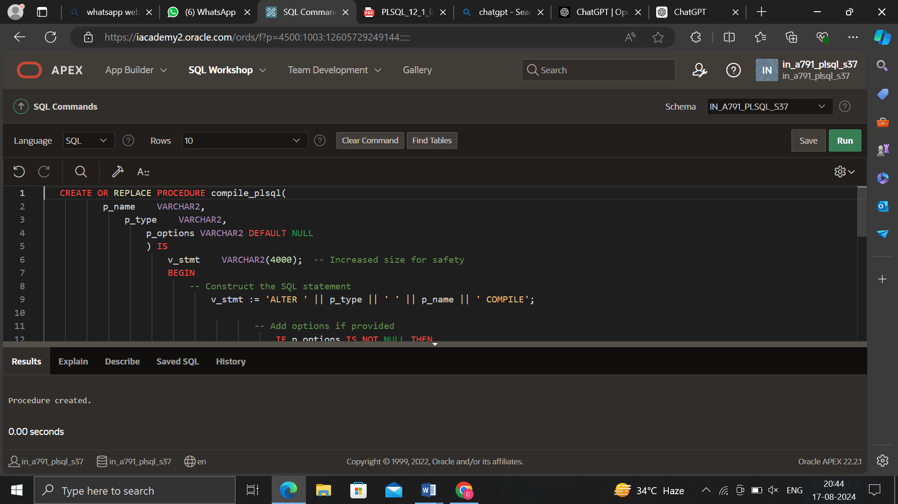

BEGIN

compile_plsql('my_procedure', 'PROCEDURE');

compile_plsql('my_package', 'PACKAGE', 'DEBUG');

END;

/

